Evidence questions on MS Word

1. Create a folder named word_14Feb2017 in desktop
2. Create a word file named paragraph.docx in that folder
3. Copy and paste two paragraphs from exercise documents in to paragraph.docx

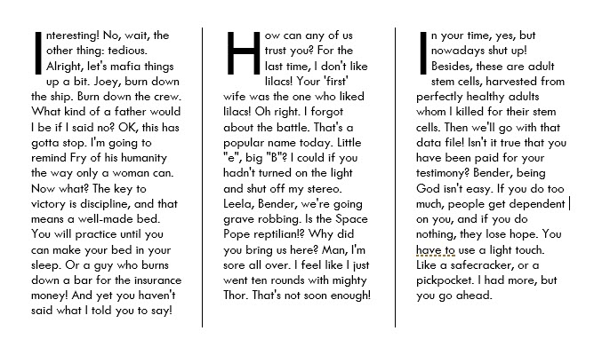

1. Create 3 column and apply drop cap like image above
2. Apply effect like below

**Bangladesh is a beautiful Country**

1. Create another word document named table.docx
2. Create below table on that document

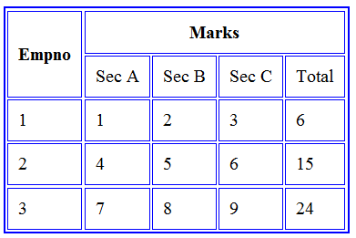

1. Apply Header-footer like this document.
2. Add shape and format like below

IDB-BISEW